Batch: A2 Roll No.: 16010322014
Experiment / assignment / tutorial No. 7
Grade: AA / AB / BB / BC / CC / CD /DD
Signature of the Staff In-charge with date

Title: Configuring EtherChannel

Objectives:
Part 1: Configure Basic Switch Settings
Part 2: Configure PAgP
Part 3: Configure LACP

OUTCOME:
CO 3. Understand and classify dynamic routing protocols

Tools required:
Packet Tracer software

Theory:
Link aggregation allows the creation of logical links that are comprised of two or more physical links. This provides increased throughput beyond using only one physical link. Link aggregation also provides redundancy if one of the links fails.
In this lab, you will configure EtherChannel, a form of link aggregation used in switched networks. You will configure EtherChannel using Port Aggregation Protocol (PAgP) and Link Aggregation Control Protocol (LACP).
Note: PAgP is a Cisco-proprietary protocol that you can only run on Cisco switches and on switches that are licensed vendors to support PAgP. LACP is a link aggregation protocol that is defined by IEEE 802.3ad, and it is not associated with any specific vendor.
LACP allows Cisco switches to manage Ethernet channels between switches that conform to the 802.3ad protocol. You can configure up to 16 ports to form a channel. Eight of the ports are in active mode and the other eight are in standby mode. When any of the active ports fail, a standby port becomes active. Standby mode works only for LACP, not for PAgP.

Task:
Topology

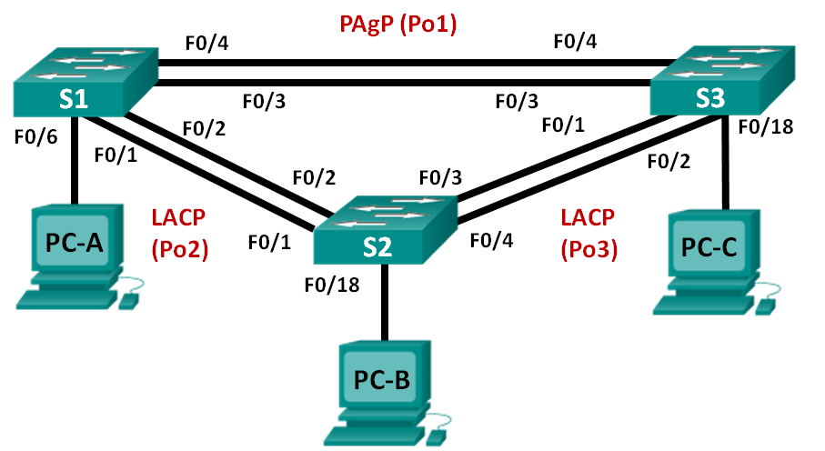

Addressing Table
Device | Interface | IP Address | Subnet Mask
S1 | VLAN 99 | 192.168.99.11 | 255.255.255.0
S2 | VLAN 99 | 192.168.99.12 | 255.255.255.0
S3 | VLAN 99 | 192.168.99.13 | 255.255.255.0
PC-A | NIC | 192.168.10.1 | 255.255.255.0
PC-B | NIC | 192.168.10.2 | 255.255.255.0
PC-C | NIC | 192.168.10.3 | 255.255.255.0

- Configure Basic Switch Settings
In Part 1, you will set up the network topology and configure basic settings, such as the interface IP addresses, device access, and passwords.
  - Cable the network as shown in the topology.
Attach the devices as shown in the topology diagram, and cable as necessary.

  - Initialize and reload the switches. 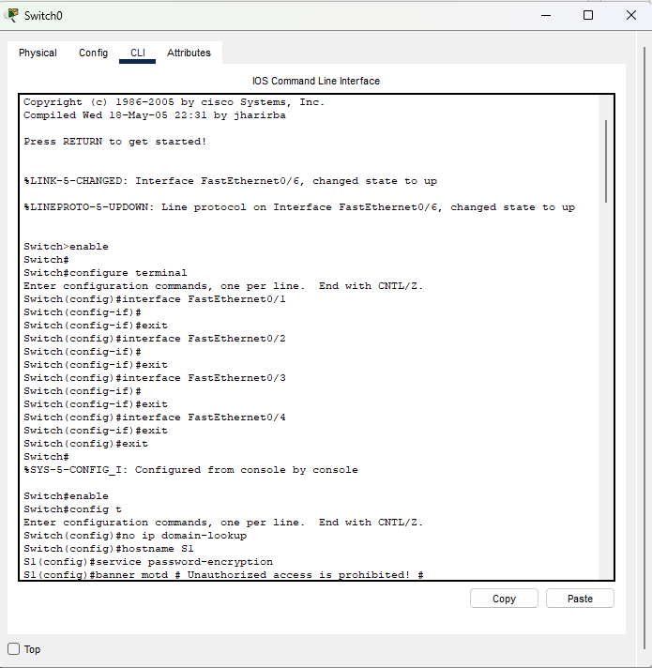
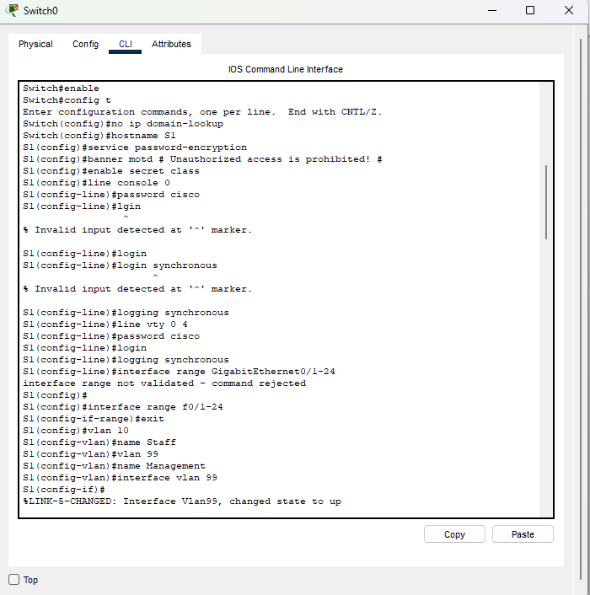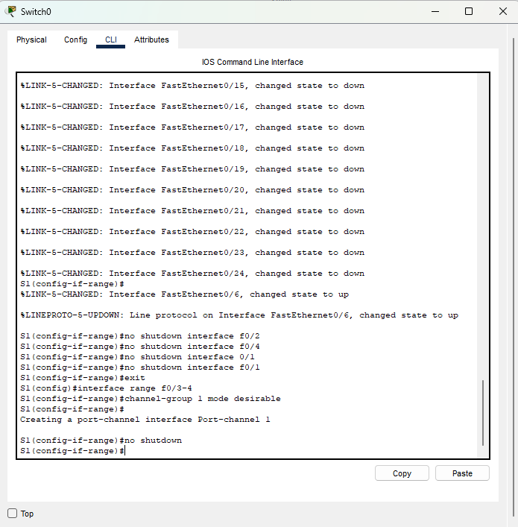
  - Configure basic settings for each switch.
    - Disable DNS lookup.
    - Configure the device name as displayed in the topology.
    - Encrypt plain text passwords.
    - Create a MOTD banner warning users that unauthorized access is prohibited.
    - Assign class as the encrypted privileged EXEC mode password.
    - Assign cisco as the console and vty password and enable login.
    - Configure logging synchronous to prevent console message from interrupting command entry.
    - Shut down all switchports except the ports connected to PCs.
    - Configure VLAN 99 and name it Management.
    - Configure VLAN 10 and name it Staff.
    - Configure the switch ports with attached hosts as access ports in VLAN 10.
    - Assign the IP addresses according to the Addressing Table.
    - Copy the running configuration to startup configuration.
  - Configure the PCs.
Assign IP addresses to the PCs according to the Addressing Table.
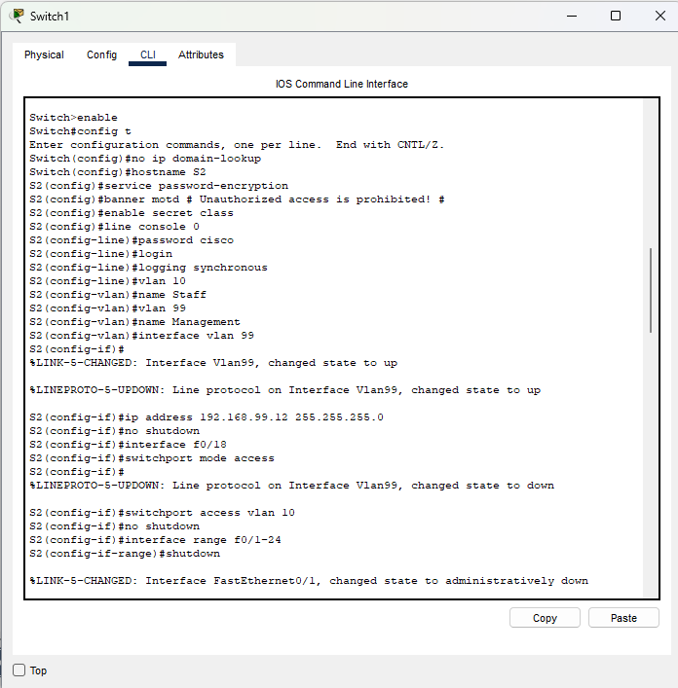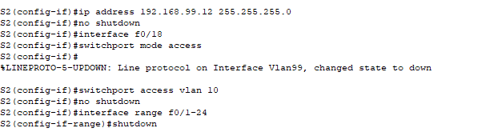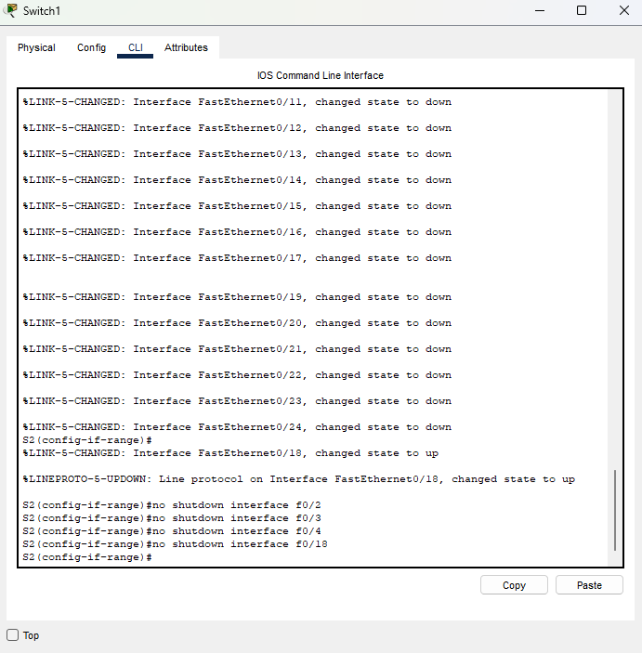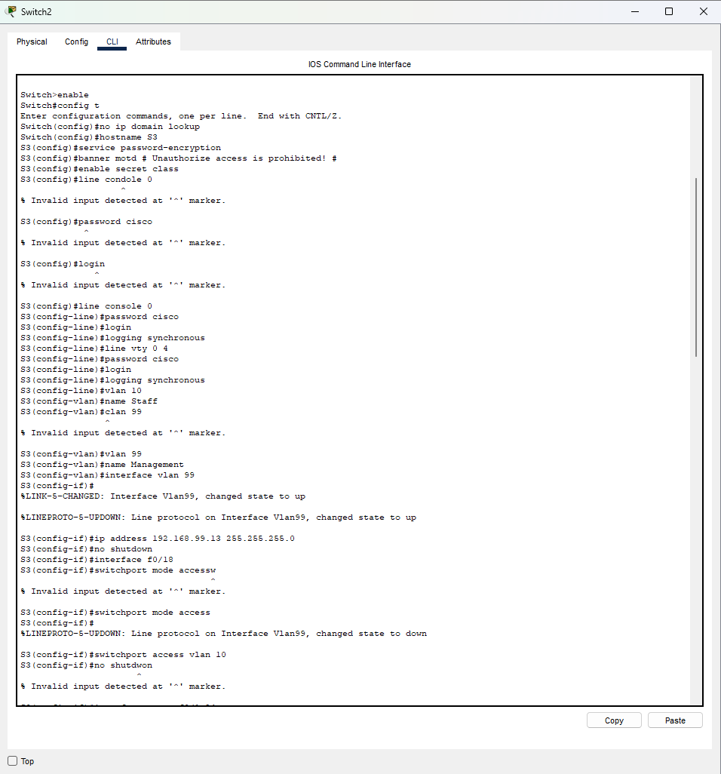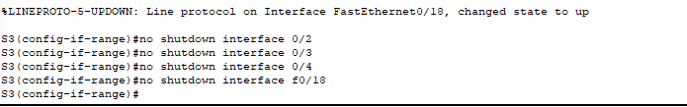

- Configure PAgP
PAgP is a Cisco proprietary protocol for link aggregation. In Part 2, a link between S1 and S3 will be configured using PAgP.
  - Configure PAgP on S1 and S3.
For a link between S1 and S3, configure the ports on S1 with PAgP desirable mode and the ports on S3 with PAgP auto mode. Enable the ports after PAgP modes have been configured.
S1(config)# interface range f0/3-4
S1(config-if-range)# channel-group 1 mode desirable
Creating a port-channel interface Port-channel 1

S1(config-if-range)# no shutdown

S3(config)# interface range f0/3-4
S3(config-if-range)# channel-group 1 mode auto
Creating a port-channel interface Port-channel 1

S3(config-if-range)# no shutdown
*Mar 1 00:09:12.792: %LINK-3-UPDOWN: Interface FastEthernet0/3, changed state to up
*Mar 1 00:09:12.792: %LINK-3-UPDOWN: Interface FastEthernet0/4, changed state to up
S3(config-if-range)#
*Mar 1 00:09:15.384: %LINEPROTO-5-UPDOWN: Line protocol on Interface FastEthernet0/3, changed state to up
*Mar 1 00:09:16.265: %LINEPROTO-5-UPDOWN: Line protocol on Interface FastEthernet0/4, changed state to up
S3(config-if-range)#
*Mar 1 00:09:16.357: %LINK-3-UPDOWN: Interface Port-channel1, changed state to up
*Mar 1 00:09:17.364: %LINEPROTO-5-UPDOWN: Line protocol on Interface Port-channel1, changed state to up
*Mar 1 00:09:44.383: %LINEPROTO-5-UPDOWN: Line protocol on Interface Vlan1, changed state to up
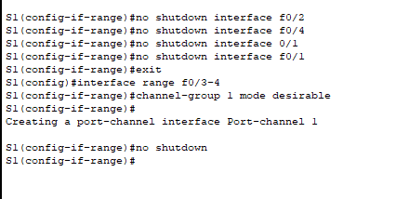
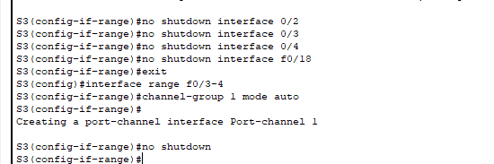
  - Examine the configuration on the ports.
Currently the F0/3, F0/4, and Po1 (Port-channel1) interfaces on both S1 and S3 are in access operational mode with the administrative mode in dynamic auto. Verify the configuration using the show run interface interface-id and show interfaces interface-id switchport commands, respectively. The example configuration outputs for F0/3 on S1 are as follows:
S1# show run interface f0/3
Building configuration...

Current configuration : 103 bytes
!
interface FastEthernet0/3
channel-group 1 mode desirable

S1# show interfaces f0/3 switchport
Name: Fa0/3
Switchport: Enabled
Administrative Mode: dynamic auto
Operational Mode: static access (member of bundle Po1)
Administrative Trunking Encapsulation: dot1q
Operational Trunking Encapsulation: native
Negotiation of Trunking: On
Access Mode VLAN: 1 (default)
Trunking Native Mode VLAN: 1 (default)
Administrative Native VLAN tagging: enabled

Voice VLAN: none
Administrative private-vlan host-association: none
Administrative private-vlan mapping: none
Administrative private-vlan trunk native VLAN: none
Administrative private-vlan trunk Native VLAN tagging: enabled
Administrative private-vlan trunk encapsulation: dot1q
Administrative private-vlan trunk normal VLANs: none
Administrative private-vlan trunk associations: none
Administrative private-vlan trunk mappings: none
Operational private-vlan: none
Trunking VLANs Enabled: ALL
Pruning VLANs Enabled: 2-1001
Capture Mode Disabled
Capture VLANs Allowed: ALL

Protected: false
Unknown unicast blocked: disabled
Unknown multicast blocked: disabled
Appliance trust: none
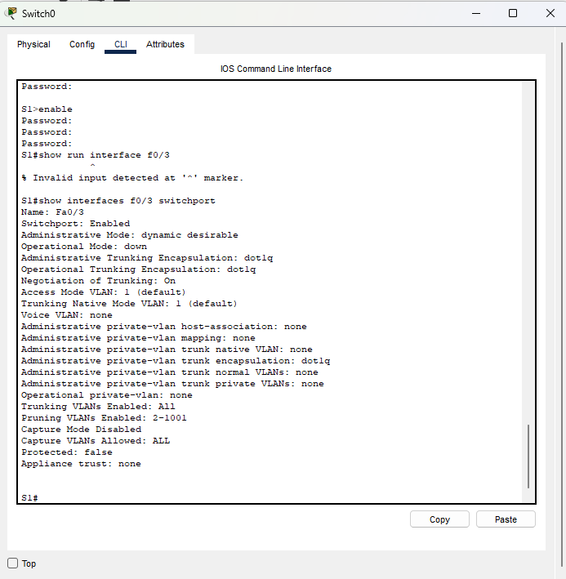
  - Verify that the ports have been aggregated.
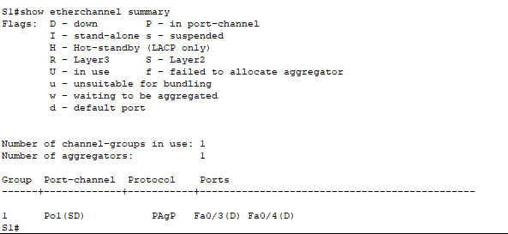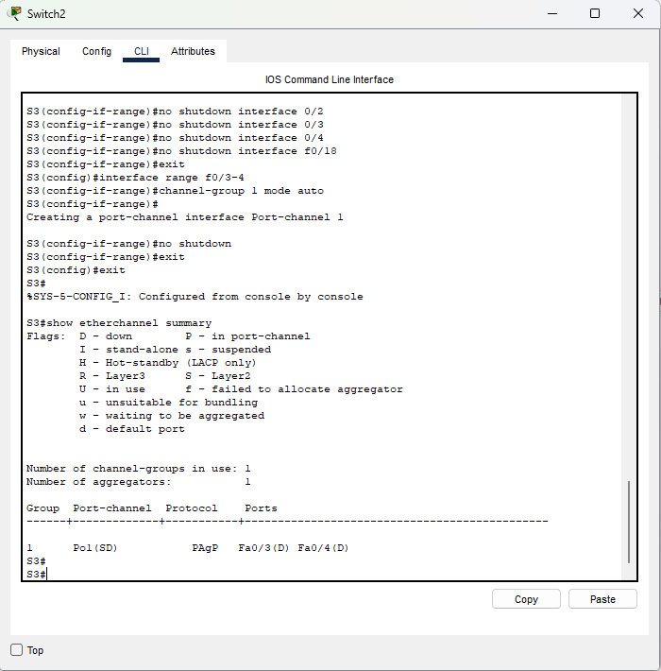
S1# show etherchannel summary
Flags: D - down P - bundled in port-channel
I - stand-alone s - suspended
H - Hot-standby (LACP only)
R - Layer3 S - Layer2
U - in use f - failed to allocate aggregator

M - not in use, minimum links not met
u - unsuitable for bundling
w - waiting to be aggregated
d - default port

Number of channel-groups in use: 1
Number of aggregators: 1

Group Port-channel Protocol Ports
------+-------------+-----------+-----------------------------------------------

1 Po1(SU) PAgP Fa0/3(P) Fa0/4(P)

S3# show etherchannel summary
Flags: D - down P - bundled in port-channel
I - stand-alone s - suspended
H - Hot-standby (LACP only)
R - Layer3 S - Layer2
U - in use f - failed to allocate aggregator

M - not in use, minimum links not met
u - unsuitable for bundling
w - waiting to be aggregated
d - default port

Number of channel-groups in use: 1
Number of aggregators: 1

Group Port-channel Protocol Ports
------+-------------+-----------+-----------------------------------------------
1 Po1(SU) PAgP Fa0/3(P) Fa0/4(P)
What do the flags, SU and P, indicate in the Ethernet summary?
The flag P indicates that the ports are bundled in a port-channel. The flag S indicates that the port-channel is a Layer 2 EtherChannel. The U flag indicates that the EtherChannel is in use.

  - Configure trunk ports.
After the ports have been aggregated, commands applied at the port channel interface affect all the links that were bundled together. Manually configure the Po1 ports on S1 and S3 as trunk ports and assign them to native VLAN 99.
S1(config)# interface port-channel 1
S1(config-if)# switchport mode trunk
S1(config-if)# switchport trunk native vlan 99
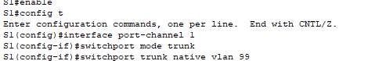
S3(config)# interface port-channel 1
S3(config-if)# switchport mode trunk
S3(config-if)# switchport trunk native vlan 99
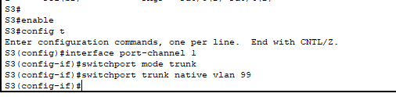
  - Verify that the ports are configured as trunk ports.
    - Issue the show run interface interface-id commands on S1 and S3. What commands are listed for F0/3 and F0/4 on both switches? Compare the results to the running configuration for the Po1 interface? Record your observation.
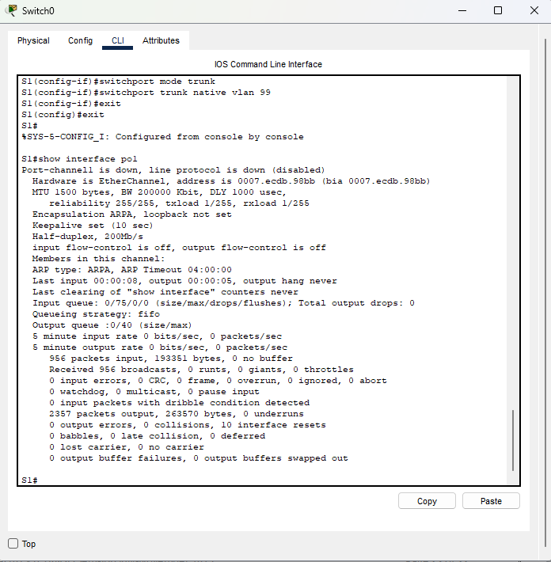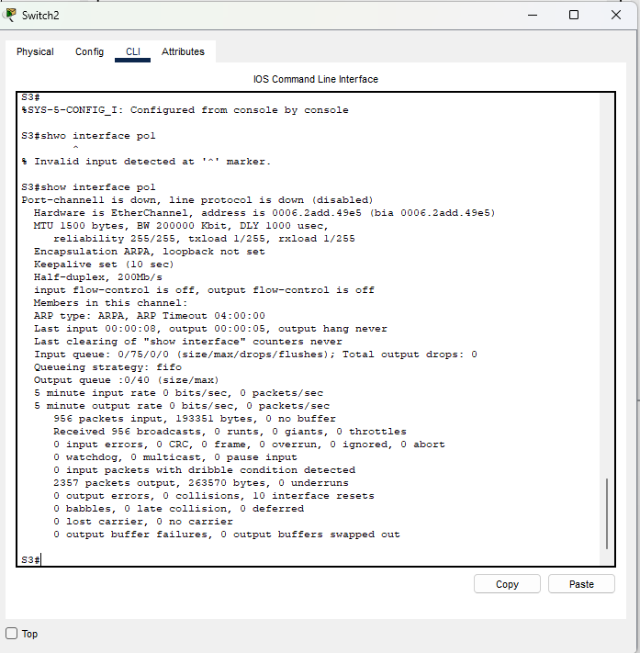
    - Issue the show interfaces trunk and show spanning-tree commands on S1 and S3. What trunk port is listed? What is the native VLAN? What is concluding result from the output?
The trunk port listed is Po1. The native VLAN is 99. After the links are bundled, only the aggregated interface is listed in some show commands.
From the show spanning-tree output, what is port cost and port priority for the aggregated link?
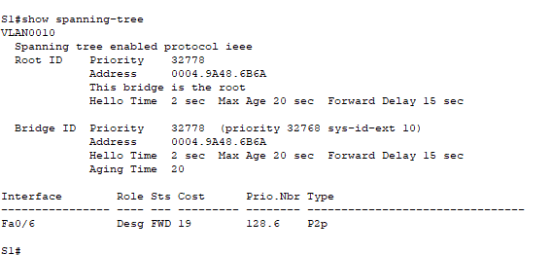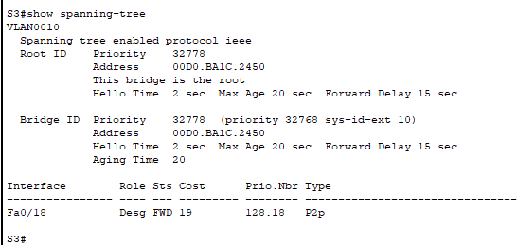
- Configure LACP
LACP is an open source protocol for link aggregation developed by the IEEE. In Part 3, the link between S1 and S2, and the link between S2 and S3 will be configured using LACP. Also, the individual links will be configured as trunks before they are bundled together as EtherChannels.
  - Configure LACP between S1 and S2.
S1(config)# interface range f0/1-2
S1(config-if-range)# switchport mode trunk
S1(config-if-range)# switchport trunk native vlan 99
S1(config-if-range)# channel-group 2 mode active
Creating a port-channel interface Port-channel 2

S1(config-if-range)# no shutdown

S2(config)# interface range f0/1-2
S2(config-if-range)# switchport mode trunk
S2(config-if-range)# switchport trunk native vlan 99
S2(config-if-range)# channel-group 2 mode passive
Creating a port-channel interface Port-channel 2

S2(config-if-range)# no shutdown
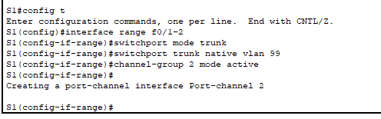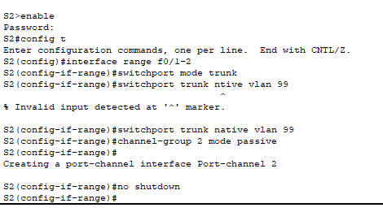
  - Verify that the ports have been aggregated.
What protocol is Po2 using for link aggregation? Which ports are aggregated to form Po2? Record the command used to verify.
Po2 is using LACP and F0/1 and F0/2 are aggregated to form Po2.
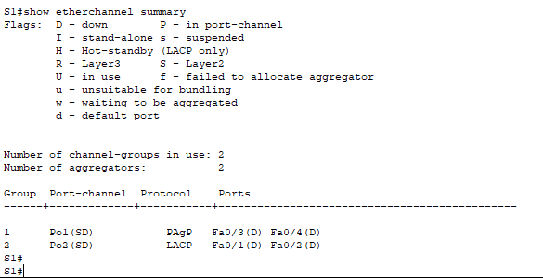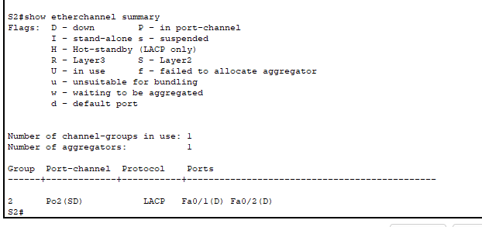

  - Configure LACP between S2 and S3.
    - Configure the link between S2 and S3 as Po3 and use LACP as the link aggregation protocol.
S2(config)# interface range f0/3-4
S2(config-if-range)# switchport mode trunk
S2(config-if-range)# switchport trunk native vlan 99
S2(config-if-range)# channel-group 3 mode active
Creating a port-channel interface Port-channel 3
S2(config-if-range)# no shutdown

S3(config)# interface range f0/1-2
S3(config-if-range)# switchport mode trunk
S3(config-if-range)# switchport trunk native vlan 99
S3(config-if-range)# channel-group 3 mode passive
Creating a port-channel interface Port-channel 3

S3(config-if-range)# no shutdown
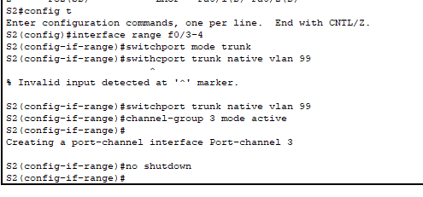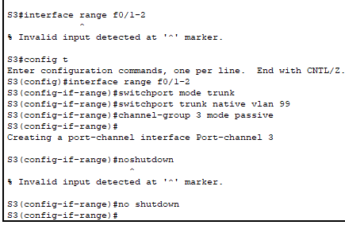
    - Verify that the EtherChannel has formed.
  - Verify end-to-end connectivity.
Verify that all devices can ping each other within the same VLAN. If not, troubleshoot until there is end-to-end connectivity.
Note: It may be necessary to disable the PC firewall to ping between PCs.
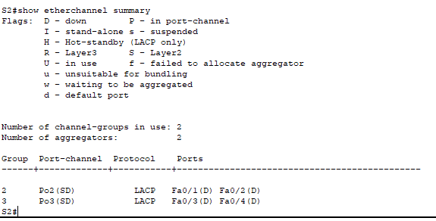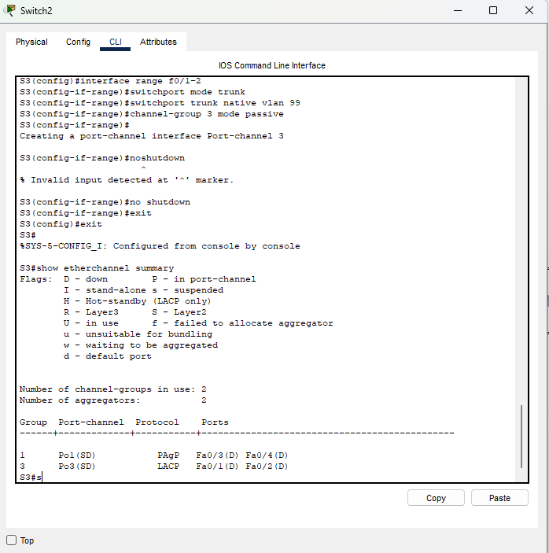
Reflection
What could prevent EtherChannels from forming?
Configuration mismatch, such as trunk port on one end and access port at the other end, different aggregation protocols and different port speed/duplex, would prevent the formation of EtherChannel.

Signature of faculty in-charge

